SAMPLE NEWSLETTER ARTICLE

The Well Visit Planner: Making the Most of Your Child’s Well-Child Visits to the Health Care Provider
Busy families, busy health care providers! Time is of the essence for everybody, and so making the best use of the time we have is critical. Well-child visits—those regularly scheduled trips to the doctor for your child’s checkups and shots—provide an important time with your child’s health care provider.

The Well-Child Visit
The American Academy of Pediatrics (AAP) recommends 13 well-child visits during the first three years of your child’s life. These are over and beyond any visits for illness or those with specialists. Well-child visits are all about prevention and promotion of healthy habits. Recommended vaccinations are given during these visits, as well as routine screenings for such things as vision or hearing problems, anemia, autism, and other issues. It is the perfect time to share what your child is doing and learning, and to share any questions or concerns you might have.

It’s also a good time for your child’s health care provider to learn about your family and your cultural and family traditions and anything that affects your child’s health and development.

The Well Visit Planner
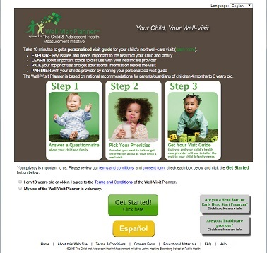
A new tool can help you make those visits as meaningful as possible: the Well Visit Planner. The Well Visit Planner is an online tool to help families prepare for their children’s upcoming well-child visits to the health care provider.
- It’s free to use
- It is available in English and Spanish
- It takes 10-15 minutes to fill out before each visit
- It can be printed and taken to a visit to help your and your child’s doctor discuss your child.
- It helps families be better partners in their child’s health care, and helps health care providers better serve the needs of the child and the family.

To use the Well Visit Planner, go to: www.WellVisitPlanner.org .

To learn more about the Well Visit Planner, check out two videos:
- The Well Visit Planner, Part 1—Making the Most of your Child’s Health Care Checkups: An overview of the Well Visit Planner
- The Well Visit Planner, Part 2—Using the Well Visit Planner: A Step-by Step Guide: A tour of the Planner—the steps involved and the kinds of questions it asks.

The Well Visit Planner (WVP) was developed and created by the Child and Adolescent Health Measurement Initiative (CAHMI) (www.cahmi.org). National experts, families, and pediatric providers worked together in the design, development, and testing of the WVP. The information contained in the WVP is based on the American Academy of Pediatrics Bright Futures Guidelines for the Health Supervision of Infants, Children, and Adolescents (https://brightfutures.aap.org)

