SAMPLE NEWSLETTER ARTICLE
What is a Well-Child Visit—and Why are They Important?
The American Academy of Pediatrics (AAP) recommends 13 well-child visits during the first three years of your child’s life. These are over and beyond any visits for illness or those with specialists. That sounds like a lot of visits! Why take your child to the doctor if he or she isn’t sick?
When your child is sick, the most important priority for you and your doctor is figuring out what is wrong and what to do to make it better. There is rarely time to discuss other topics about how your child is growing and developing.
Well-child visits are all about prevention and promotion of healthy habits. Recommended vaccinations are given during these visits, as well as routine screenings for such things as vision or hearing problems, anemia, autism, and other issues. It is the perfect time to share what your child is doing and learning, and to share any questions or concerns you might have.
It’s also a good time for your child’s health care provider to learn about your family and your cultural and family traditions and anything that affects your child’s health and development. They also provide a time for the child to get to know and be more comfortable with the health care provider so that the office is not such a scary place if the child is ill or hurt.
Seven of the 13 visits happen in the first year: newborn, first week, 1 month, 2 months, 4 months, 6 months, and 9 months. This is a time when babies are rapidly growing and learning new skills! The visits space out over the next 2 years: 12 months, 15 months, 18 months, 2 years, 2 1/2 years, and 3 years. Beyond 3 years, well-child visits are usually scheduled once a year.
Well-child visits are important for every child—including children and youth with special health care needs. Even the child with the most severe special health issues or disabilities still needs good nutrition, oral care, safety precautions and other health promotion information.
The Well Visit Planner
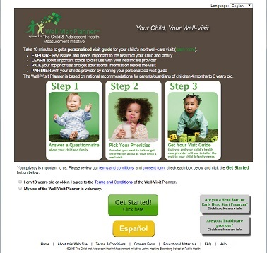
A new tool can help you make those visits as meaningful as possible: the Well Visit Planner. The Well Visit Planner is an online tool to help families prepare for their children’s upcoming well-child visits to the health care provider. It’s free to use; is available in English and Spanish; takes 10-15 minutes to fill out before each visit; and can be printed and taken to a visit to help your and your child’s doctor discuss your child. It helps families be better partners in their child’s health care, and helps health care providers better serve the needs of the child and the family.

To use the Well Visit Planner, go to: www.WellVisitPlanner.org .

To learn more about the Well Visit Planner, check out two videos:
- The Well Visit Planner, Part 1—Making the Most of your Child’s Health Care Checkups: An overview of the Well Visit Planner
- The Well Visit Planner, Part 2—Using the Well Visit Planner: A Step-by Step Guide: A tour of the Planner—the steps involved and the kinds of questions it asks.

The Well Visit Planner (WVP) was developed and created by the Child and Adolescent Health Measurement Initiative (CAHMI) (www.cahmi.org). National experts, families, and pediatric providers worked together in the design, development, and testing of the WVP. The information contained in the WVP is based on the American Academy of Pediatrics Bright Futures Guidelines for the Health Supervision of Infants, Children, and Adolescents (https://brightfutures.aap.org)

