SAMPLE FACEBOOK POST

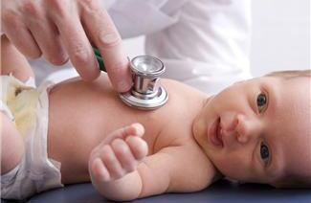
The Well Child Visit
The American Academy of Pediatrics (AAP) recommends 13 well-child visits during the first three years of your child’s life. These are over and beyond any visits for illness or those with specialists. Well-child visits are all about prevention and promotion of healthy habits. Recommended vaccinations are given during these visits, as well as routine screenings for such things as vision or hearing problems, anemia, autism, and other issues. It is the perfect time to share what your child is doing and learning, and to share any questions or concerns you might have.

It’s also a good time for your child’s health care provider to learn about your family and your cultural and family traditions and anything that affects your child’s health and development.

To learn about a tool to help you plan out your child’s well visits so that you spend that time on topics most relevant to your child’s health and development at the time, go to www.WellVisitPlanner.org.

For more resources and information about the Well Visit Planner, go to [link to toolkit]

