SAMPLE NEWSLETTER ARTICLE
The Child with Special Health Care Needs and the Well-Child Visit
The American Academy of Pediatrics (AAP) recommends 13 well-child visits during the first three years of your child’s life. Well-child visits are all about prevention and promotion of healthy habits. Recommended vaccinations are given during these visits, as well as routine screenings for such things as vision or hearing problems, anemia, autism, and other issues. It is the perfect time to share what your child is doing and learning, and to share any questions or concerns you might have.
If Your Child Has Special Health Care Needs, Does He or She Still Need These Additional Health Care Visits?

Yes! Every child needs well child visits! Even the child with the most severe special health care issues or disabilities still needs good information on healthy eating, oral health care, and safety precautions. The information can be tailored to fit the needs and abilities of the child, but it is still important.

The Well Visit Planner: A Tool to Help You Make the Most of Your Well Child Visits

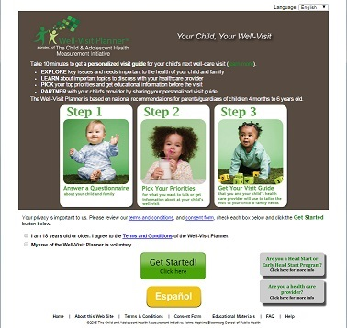
A new tool can help you make those visits as meaningful as possible: the Well Visit Planner. The Well Visit Planner is an online tool to help families prepare for their children’s upcoming well-child visits to the health care provider. It’s free to use; is available in English and Spanish; takes 10-15 minutes to fill out before each visit; and can be printed and taken to a visit to help your and your child’s doctor discuss your child. It helps families be better partners in their child’s health care, and helps health care providers better serve the needs of the child and the family.

To use the Well Visit Planner, go to: www.WellVisitPlanner.org .

Using the Well Visit Planner for Children with Special Health Care Needs

You can adapt how you use the Planner depending on your child’s special health care needs. For example, your child may have a developmental delay. If so, it may be more helpful to complete the questionnaire about your child’s developmental age, not his or her actual age.

Use the Planner as a tool to help you think through the topics around promoting good health and preventing illness and accidents for your child.

The Well Visit Planner can also give you ideas of questions to ask your child’s specialists or other health care providers.

To Learn More about the Well Visit Planner

To learn more about the Well Visit Planner, check out two videos:
- The Well Visit Planner, Part 1—Making the Most of your Child’s Health Care Checkups: An overview of the Well Visit Planner
- The Well Visit Planner, Part 2—Using the Well Visit Planner: A Step-by Step Guide: A tour of the Planner—the steps involved and the kinds of questions it asks.

The Well Visit Planner (WVP) was developed and created by the Child and Adolescent Health Measurement Initiative (CAHMI) (www.cahmi.org). National experts, families, and pediatric providers worked together in the design, development, and testing of the WVP. The information contained in the WVP is based on the American Academy of Pediatrics Bright Futures Guidelines for the Health Supervision of Infants, Children, and Adolescents (https://brightfutures.aap.org)

